6SENG002W Concurrent Programming

FSP Process Analysis & Design Form

Name | Pasan Kottearachchi
Student ID | W1761885
Date | 28/12/2022

1. FSP Process Attributes

Attribute | Value
Name | PRINTER
Description | This is a shared printer that is used by the students for printing documents and the technician to refill the papers
Alphabet | {stud_1, stud_2, tech}.{documentPrint[1..3], stud.{acquire, release}, technician.{acquire, refillPrinterSheets, release}}
Number of States | 18
Deadlocks (yes/no) | No
Deadlock Trace(s)  (if applicable) | N/A

2. FSP Process Code

FSP Process:
//Define the CONSTANTS of the system
const MAX_NO_OF_PAPER = 3
range PAPER_RANGE = 1 .. MAX_NO_OF_PAPER

//Initialise the process of printer
PRINTER(SHEET_COUNT = MAX_NO_OF_PAPER) = PRINT_PAPER[SHEET_COUNT],
PRINT_PAPER[sheet : 0 .. SHEET_COUNT ] = (
when(sheet > 0) stud.acquire -> documentPrint[PAPER_RANGE] -> stud.release ->
PRINT_PAPER[sheet - 1]
|
when (sheet == 0) technician.acquire -> technician.refillPrinterSheets -> technician.release ->
PRINT_PAPER[MAX_NO_OF_PAPER]
) .

3. Actions Description
A description of what each of the FSP process' actions represents, i.e. is modelling. In addition, indicate if the action is intended to be synchronised (shared) with another process or asynchronous (not shared). (Add rows as necessary.)

Actions | Represents | Synchronous or Asynchronous
stud.acquire | Student acquire the control of the printing process. | Synchronous
documentPrint[1] | Printing the document 1 | Synchronous
documentPrint[2] | Printing the document 2 | Synchronous
documentPrint[3] | Printing the document 3 | Synchronous
stud.release | Student release the printer after printing a document. | Synchronous
technician.acquire | Technician acquire to control of the printing process. | Synchronous
technician.refillPrinter Sheets | Technician refilling the sheets. | Synchronous
technician.release | Technician release the printer after refilling the sheets. | Synchronous

4. FSM/LTS Diagrams of FSP Process
Note that if there are too many states, more than 64, then the LTSA tool will not be able to draw the diagram. In this case draw small diagrams of the most important parts of the complete diagram.

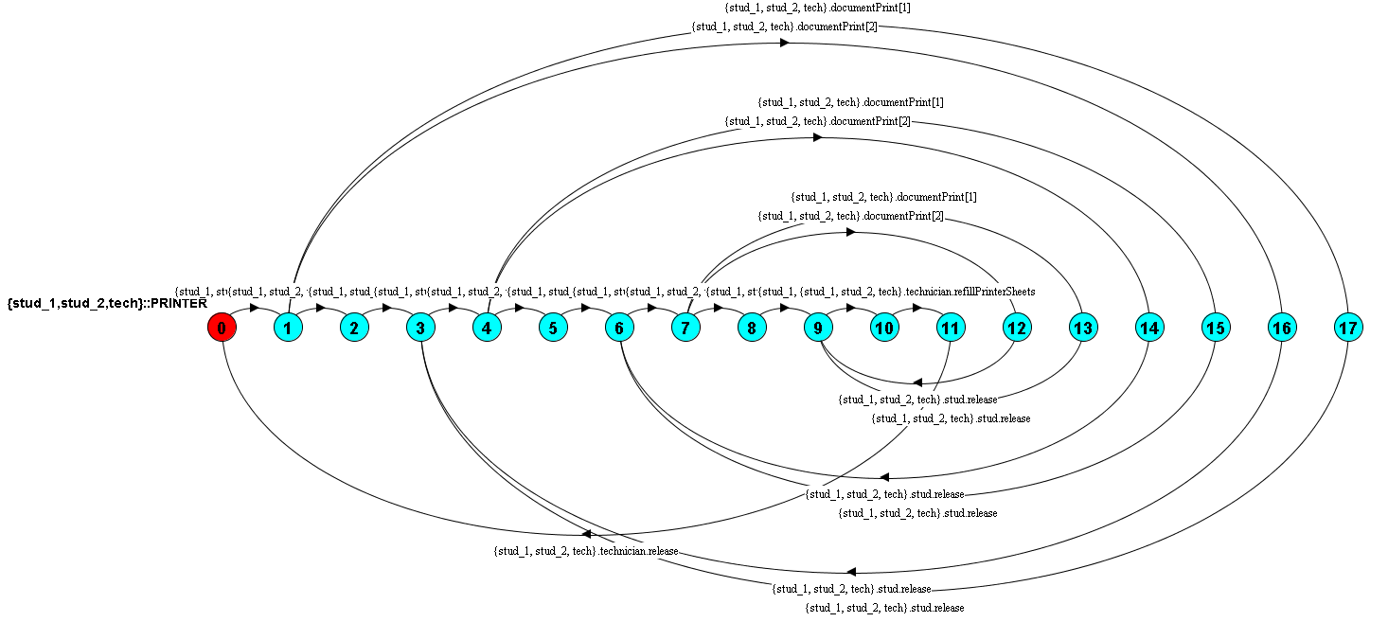

5. LTS States
A description of what each of the FSP process' states represents, i.e. is modelling. If there are a large number of states then you can group similar states together &/or only include the most important ones. For example, identify any states related to mutual exclusion (ME) & the associated critical section (CS), e.g. waiting to enter the CS state, in the CS state(s), left the CS state. (Add rows as necessary.)

State | Represents
0 | Printer is acquired to be used student.
1, 4, 7 | Student has acquired to control the printer.
2, 5, 8, 12, 13, 14, 15, 16, 17 | Document has been printed.
3, 6, 9 | Student releases the printer after printing
10 | Technician has acquired the printer to refill the sheets.
11 | Technician refilled the sheets and the printer ready to be used

6. Trace Tree for FSP Process
The trace tree for the process. Use the conventions given in the lecture notes and add explanatory notes if necessary.
